006BC2744 - Day 23 (17 August 2026)

Brownfield vs. Greenfield

1. What distinguishes a Brownfield application from a Greenfield one?
A Brownfield application already exists and carries legacy code, integrations, technical debt, and business constraints. A Greenfield application is built from scratch, providing greater architectural freedom but without the benefit of existing functionality.

2. Why is Brownfield modernization more complex?
Modernization must preserve existing business behavior while changing the underlying technology. Hidden dependencies, outdated components, and limited documentation can make analysis and migration riskier than a Greenfield build.

💼 Business Drivers

3. How do business drivers influence migration decisions?
Drivers such as cost reduction, faster delivery, scalability, and regulatory compliance determine why and how an application should be modernized. They help prioritize initiatives based on business value rather than technology alone.

4. Can modernization be justified purely on technical grounds?
Technical issues can trigger modernization, but a strong business case usually requires measurable business benefits such as reduced cost, lower risk, improved agility, or better customer experience.

📊 Application Portfolio Assessment

5. What is the purpose of application portfolio assessment?
It evaluates the application landscape, including business value, technical health, dependencies, cost, and risk, to determine which applications should be modernized, retired, or migrated.

6. How does inventorying applications and dependencies reduce risk?
It provides visibility into what systems exist and how they interact. This helps identify critical dependencies early and prevents unexpected failures during migration.

🔍 Discovery & Mapping

7. Why is mapping integration points critical?
Applications often depend on APIs, databases, messaging systems, and external services. Mapping these integrations helps define migration sequencing and avoids breaking downstream or upstream systems.

8. How can overlooked dependencies derail migration?
A missed dependency can cause application failures, data issues, or unavailable services after migration. It may also force unplanned rollback or additional remediation work.

⚖️ Technical Debt & Stack Evaluation

9. How does technical debt impact modernization strategy?
High technical debt may make simple migration impractical and favor refactoring, replatforming, or rebuilding. Low-debt applications may be suitable for simpler migration approaches.

10. Why evaluate runtime dependencies?
Runtime dependencies such as libraries, operating systems, middleware, and databases determine compatibility with the target environment. They can reveal blockers, unsupported components, and modernization efforts.

🗄 Database & Infrastructure

11. What are the main risks in database migration?
Common risks include data loss, incompatibility, downtime, performance changes, and inconsistent data. They can be mitigated through assessment, backups, validation, replication, and controlled cutover testing.

12. How does infrastructure assessment influence cloud-readiness?
It evaluates compute, storage, networking, OS, middleware, performance, and licensing requirements. The results determine whether the application can move directly to the cloud or needs remediation first.

🔐 Security & Compliance

13. Why reassess security and compliance during migration?
The target environment may introduce different identity, networking, encryption, and access-control mechanisms. Therefore, previous compliance does not automatically guarantee compliance after modernization.

14. How does modernization affect risk posture?
It can reduce risks by removing obsolete technology and improving patching, monitoring, and security controls. However, new cloud services, integrations, and architectures can also introduce new risks that must be managed.

🔄 Migration Strategies — 6 R’s

15. How do the 6 R’s help decision-making?
The 6 R’s—Rehost, Replatform, Refactor, Repurchase, Retire, and Retain provide a structured way to choose a migration strategy based on business value, technical condition, cost, and risk.

16. When is refactoring preferable to rehosting?
Refactoring is preferable when the goal is to significantly improve scalability, agility, maintainability, or cloud-native capabilities. Rehosting is better when speed and minimal change are the priorities.

📈 Cost & Effort Analysis

17. How does TCO differ from upfront migration cost?
TCO considers the total cost over the application's lifecycle, including infrastructure, licensing, maintenance, operations, and support. Upfront migration cost covers mainly the initial transformation effort.

18. Why are effort, complexity, and risk scoring important?
They help compare applications objectively and identify which migrations are easier, safer, and more valuable. This supports practical prioritization and wave planning.

🗂 Prioritization & Planning

19. What factors determine migration wave planning?
Factors include business criticality, dependencies, complexity, risk, readiness, resource availability, and expected value. Related or dependent applications are often grouped carefully to minimize disruption.

20. How does prioritization balance urgency with feasibility?
Business-critical applications may need faster action, but technical readiness and dependency complexity must also be considered. The goal is to maximize business value without creating unacceptable delivery risk.

🏛 Target-State Architecture & Patterns

21. How does target-state architecture guide modernization?
It defines the desired future architecture, technologies, integration model, security, and operational approach. This provides a clear direction for selecting the appropriate modernization strategy.

22. Strangler Fig vs. Anti-Corruption Layer
The Strangler Fig pattern gradually replaces parts of a legacy system with new components. An Anti-Corruption Layer protects the new system from legacy data models and interfaces while both systems coexist.

📦 Containerization & Cloud-Readiness

23. What indicates an application is cloud-ready?
Typical indicators include stateless design, externalized configuration, automated deployment, scalable components, observability, and minimal dependency on local infrastructure.

24. How does containerization support modernization?
Containers package the application and its dependencies consistently, improving portability and deployment speed. They also support orchestration, scaling, and standardized DevOps practices.

📏 Success Metrics & Roadmap

25. Why are KPIs critical for migration success?
KPIs provide measurable evidence that modernization achieved its intended outcomes, such as cost reduction, availability, deployment frequency, performance, or incident reduction.

26. How does a migration roadmap align execution with the business case?
A roadmap connects migration waves, timelines, costs, dependencies, and expected benefits. This allows stakeholders to track whether technical progress is delivering the promised business outcomes.

🛠 Tools & Documentation

27. What role do assessment tools play?
Assessment tools automate discovery and analyze application characteristics, dependencies, and technology stacks. They provide data-driven insights and reduce reliance on purely manual judgment.

28. Why is documenting findings essential?
Documentation creates a common understanding of the current state, risks, recommendations, and assumptions. It supports stakeholder decisions, approvals, knowledge transfer, and future modernization activities.

Task 1: What is Redis used for ? Why ?

Redis is an in-memory key-value data store commonly used for caching, session management, real-time data, counters, and message queues. It is very fast because frequently accessed data is kept in memory rather than read from disk.
Task 2: Can you explain the architecture of Redis with a diagram?

Redis stores data primarily in memory, while persistence mechanisms such as RDB and AOF can save data to disk and replication/cluster features provide availability and scalability.
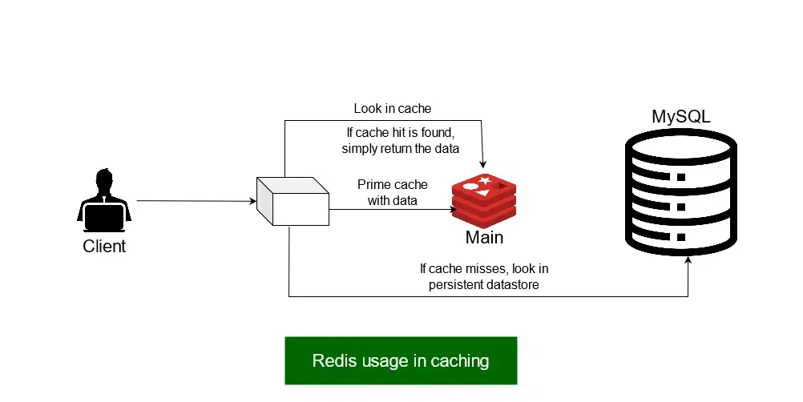

Task 3: What are the advantages of redis and also disadvantages?

Advantages: Very fast, simple key-value model, supports rich data structures, and provides features such as caching, replication, and pub/sub.

Disadvantages: Memory can be expensive and limited, data can be lost without proper persistence configuration, and it is not ideal as the primary database for every workload.

Task 4: Install docker in your system
Steps
Download from https://www.docker.com/products/docker-desktop
Run installer
Enable hyper-v
Restart the system
Check docker version in cmd
docker –version
Done installed docker ..

Task 5: Open docker from the start menu

Now check
Docker version

Use command to pull image
docker pull redis

Use the command to check image
Docker images

Task 6: Now run redis container

docker run --name myredis -p 6379:6379 -d redis
Myredis is the name of the container i m creating you can give ur own
-p 6379:6379 this will map the port no to the local host.
-d redis means we RE RUNNING IN detached mode.

Task 7: Now will test the connection
docker exec -it myredis redis-cli

Task 8: Type Ping
The output should be pong
Pong

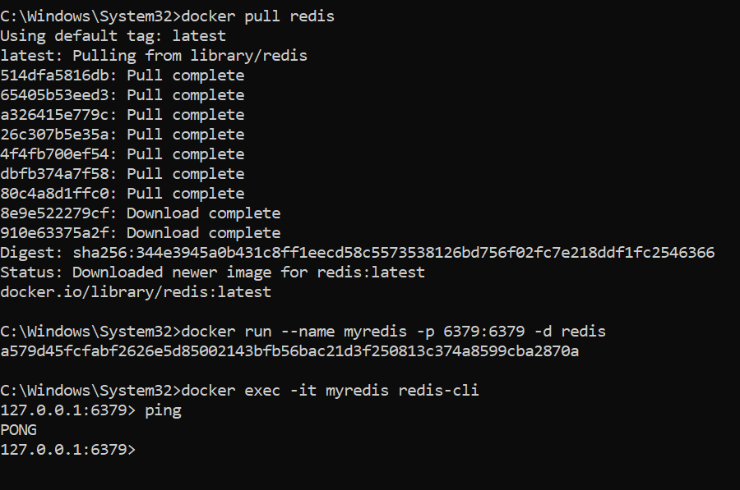

Task 9: 127.0.0.1:6379> set mykey1 "hello Prasunamba from redis"
OK
127.0.0.1:6379> get mykey1
"hello Prasunamba from redis"
127.0.0.1:6379>

Task 10: 127.0.0.1:6379> incr counter
(integer) 1
127.0.0.1:6379> get counter
"1"

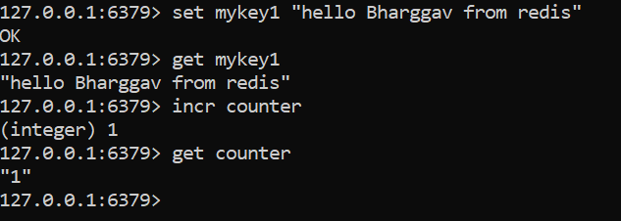

Task 11: To run hashset you need to open redis - cli
How to do that
Use command you will see redis if its working or else it will show exit status
docker ps -a

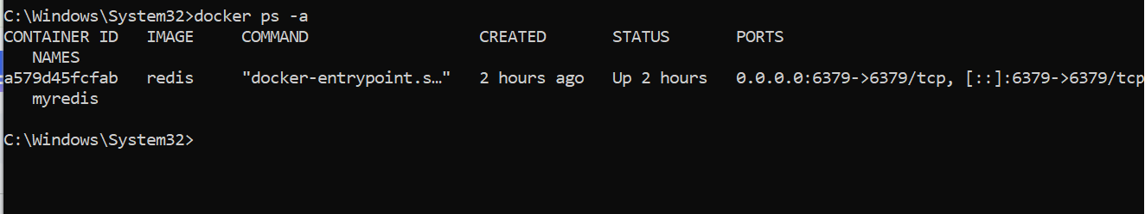

Now open another command promt
And use
HSET user:101 name "Prasunamba" email "Prasunamba.mk@gmail.com"

And get using
hgetall user:101

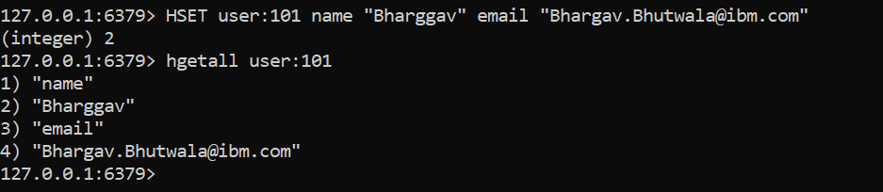

Task 12: List of ordered collections
LPUSH tasks "Task1"
LPUSH tasks "Task2"
LRANGE tasks 0 -1

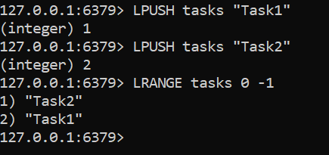

Task 13: Sets (unique value)
SADD customrs1 "Prasunamba" "Meher" "K"
SMEMBERS customrs1
SISMEMBER customrs1 "K" (sismember is checking if the value exists or not.

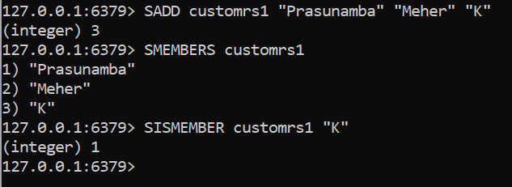

Task 14: In the same way can you check sorted sets … zsets .. What are they ?why they are used ? how to use ? can you try ?
Like zadd leaderboard 100 “Prasunamba”

Task 15:
127.0.0.1:6379> set user:1 "Prasunamba"
OK
127.0.0.1:6379> exists user:1
(integer) 1
127.0.0.1:6379> del user:1
(integer) 1
127.0.0.1:6379> keys *
1) "user:101"
2) "customrs"
3) "user"
4) "tasks"
5) "customrs1"
127.0.0.1:6379> rename user:1 user:100
(error) ERR no such key
127.0.0.1:6379> rename user:2 user:100
(error) ERR no such key
127.0.0.1:6379> set user:1 "Prasunamba"
OK
127.0.0.1:6379> rename user:1 user:100
OK
127.0.0.1:6379> keys *
1) "user:100"
2) "user:101"
3) "customrs"
4) "user"
5) "tasks"
6) "customrs1"
127.0.0.1:6379> expire session:123 10
(integer) 0
127.0.0.1:6379> expire session:123 10 ttl session:123
(error) ERR Unsupported option ttl
127.0.0.1:6379> SET session:123 "active"
OK
127.0.0.1:6379> expire session:123 10
(integer) 1
127.0.0.1:6379> ttl session:123
(integer) -2
127.0.0.1:6379> expire session:123 1000
(integer) 0
127.0.0.1:6379> ttl session:123
(integer) -2
127.0.0.1:6379> expire session:123 1000000
(integer) 0
127.0.0.1:6379> ttl session:123
(integer) -2
127.0.0.1:6379> get session:123
(nil)
127.0.0.1:6379>

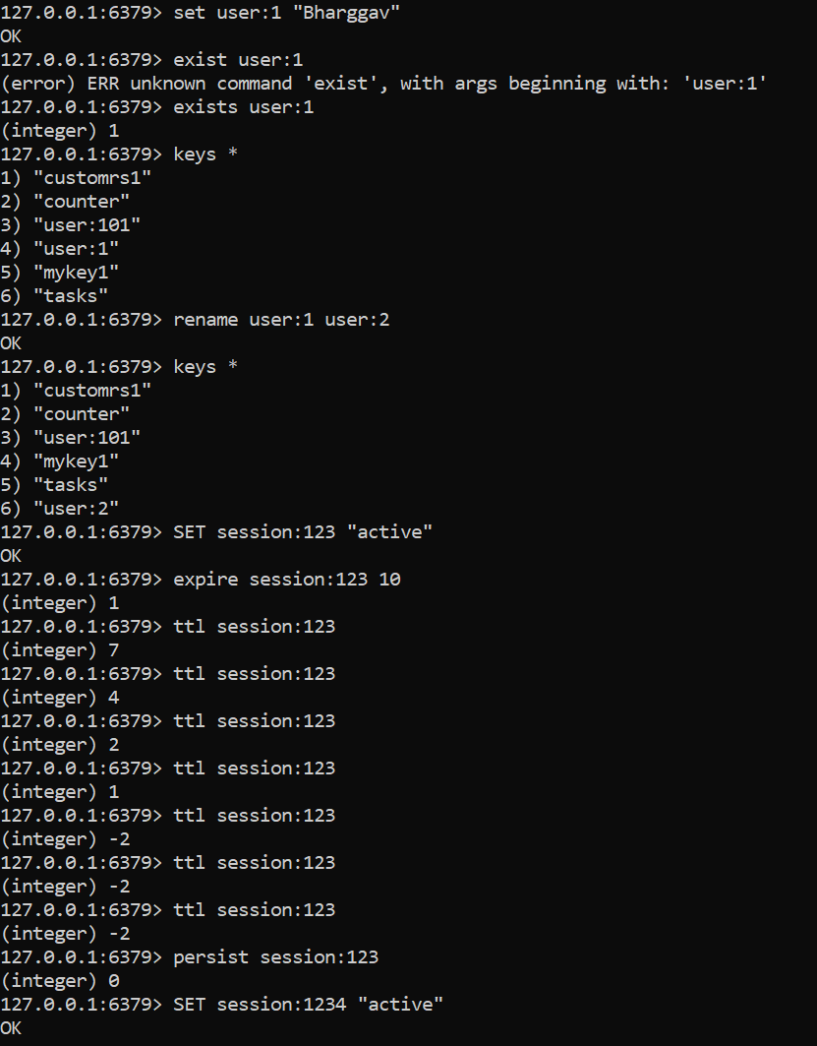

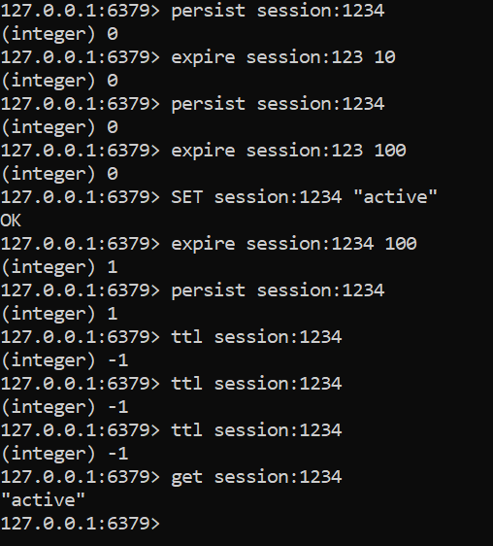

Task 16:
expire session:123 10000 // setting expiry to 10000
(integer) 1
127.0.0.1:6379> ttl session:123
(integer) 9993 // plz observe every time you check ttl it will decrease.
127.0.0.1:6379> ttl session:123
(integer) 9989 // still time to live is 9989 sec
127.0.0.1:6379> ttl session:123
(integer) 9987
127.0.0.1:6379> ttl session:123
(integer) 9985
127.0.0.1:6379> ttl session:123
(integer) 9984
127.0.0.1:6379> ttl session:123
(integer) 9983
127.0.0.1:6379> ttl session:123
(integer) 9977
127.0.0.1:6379> PERSIST session:123 // checking if still persists or not 1 says yes 0 says expired.
(integer) 1

Task 17: How does Cache‑Aside balance freshness and performance, and what risks arise if the database is updated frequently?

Cache-Aside improves performance by reading frequently accessed data from the cache and loading it from the database on a cache miss. If the database changes frequently, stale cached data and cache-invalidation race conditions can occur.

Task 18: In what type of workload would Write‑Behind caching introduce consistency challenges compared to Write‑Through?

Write-Behind can cause consistency issues in high-write, real-time workloads because changes are written to the cache first and the database asynchronously. A failure before the database update can lead to lost or delayed data, unlike Write-Through.

Task 19: Why might LFU eviction be more suitable than LRU eviction in recommendation systems?

LFU can be better because popular recommendations may be accessed repeatedly over a long period, so frequently used items remain cached. LRU may evict them if they haven't been accessed recently despite having high overall popularity.

Task 20: What are the trade‑offs between time‑based invalidation and event‑based invalidation?

Time-based invalidation (TTL) is simple and predictable but can serve stale data until the TTL expires. Event-based invalidation provides fresher data but requires reliable event delivery and adds architectural complexity.

Task 21: How would you design cache invalidation for a real‑time stock trading system?

Use very short TTLs combined with event-based invalidation whenever price/order updates occur, and avoid serving stale quotes beyond an acceptable threshold. Critical trading decisions should validate against the authoritative trading system rather than relying solely on cached data.

Task 22: How does sharding in Redis clusters improve scalability, and what complexity does it add to key management?

Redis Cluster shards data across multiple nodes using hash slots, allowing memory and throughput to scale horizontally. The trade-off is greater complexity around key design, multi-key operations, resharding, and ensuring related keys use compatible hash slots.

